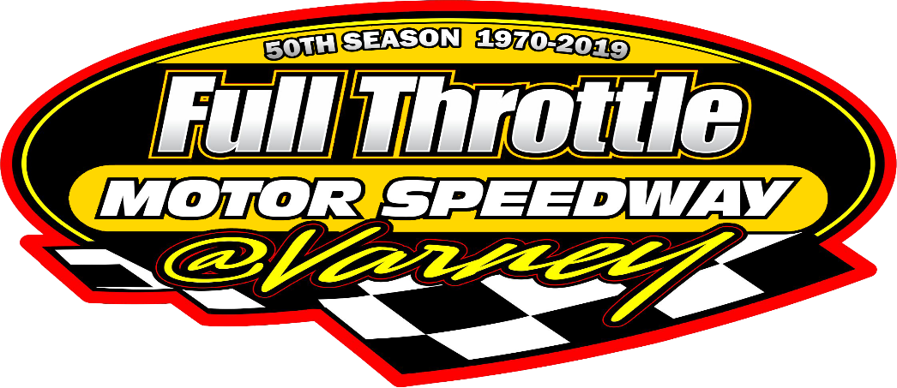

2019 FTMS CRAZY TRAIN RULES

- LEAD TRAIN VEHICLE:
The Lead vehicle MUST be able to pass post-race technical inspection as a LEGAL race vehicle. Open to any North American car, 2 door, 4 doors or station wagon or 2 wheel drive Pick-up truck. Lead vehicle must use STOCK components that are compatible with lead vehicle and pre- approved with tech. Headers with 96 Decibel mufflers will be allowed. Older or newer engine from same manufacturer of same size or smaller may be used with prior approval from FTMS official may be used but must remain stock.

- SECOND AND THIRD TRAIN CARS:
  - 1 ¾” round tubing only "6- point" roll cage is mandatory and must follow the same roll cage build rules and 2019 safety requirements as lead vehicle.

- BODY APPEARANCE:
Body must be stock appearing, in stock position on frame on stock rubber mounts. All moldings, ornaments, door handles, glass, and plastic components must be removed except grill and windshield. Outside scrub rails allowed. Driver’s door MUST be reinforced with a 1/8” flat steel plate between the cage bars and door skin. Roof panels must remain STOCK (no gutting or trimming). No aluminum body panels. Inner door panels should be stock. If door skins or fenders are replaced with body steel, they must be stock appearing. Race cars participating in racing events must be complete, stock appearing and presentable at all times. The FTMS Tech Official at any event may reject cars that are considered improperly prepared. Cars that are considered unsafe to driver, competitors, staff or fans will be rejected and not allowed on the track. No shortening or lengthening of cars. Absolutely NO screws are allowed anywhere on the race vehicles.

- BRAKES:
Stock front and rear brakes in good working condition are MANDATORY and are subject to test and inspection. Pedal must be in original position. All three cars must have working brakes.

- BUMPERS:
Stock bumpers must be mounted in stock location, front & back. All bumpers must be fastened so they will not fall off or have any sharp ends (suggest metal straps welded to frame horns and then to bumper). Homemade bumpers must not exceed stock dimensions and height for the make and model of the vehicle being used, NO EXCEPTIONS.

- DOORS:
Must be welded or bolted securely. Doors cannot be cut down. Steel Tubing (1” x 3”) Side scrub rails with tapered ends and mounted 24” off the ground mounted with Carriage bolts ONLY, running from wheel well to wheel well on both sides of each train vehicle are MANDATORY

- FIRE SAFETY/CONTROL:
Cars must have a working and approved fire extinguisher mounted in a secure mounting bracket and within driver's reach with seat belts fastened in ALL cars. Fire extinguisher must have a gauge and if the extinguisher is older than three years, it must have a recharge slip dated within 1 year. All lead cars must have two kill switches one on each side of the vehicle that are within reach of the safety crew. Kill switches are to be clearly marked ON/OFF. A driver's fireproof racing suit, shoes and gloves with a recommended rating of SFI 3.2A/1 or better is mandatory for all train car drivers. Approved Head & Neck restraints are mandatory for all train drivers and worn at all times.

- INTERIOR:
All flammable material must be removed and stock dash (dash optional). A Manufactured aluminum racing seat MUST be used and must be securely bolted to roll cage. Seat must be positioned completely to the left of the centerline of the car. A solid headrest is mandatory and is subject to test. Interiors must be vacuumed out, free off glass, screws, rivets and other debris.
PAINT AND LETTERING:
All cars must be neatly and brightly painted. Numbers and Names are assigned by the Track must be painted legible on the roof (and doors on 8"s) in min. 24” high and 2” wide on all 3 train cars. Numbers to be read from right side in a color offering distinct contrast to the color of the car.

- ROLL CAGE:
  - full "6- point" roll cage with upper “halo” is mandatory for all 2018 Crazy Train vehicles. The minimum cage with 4 door bars on driver side and 3 on right side or "x" and gussets will be the only cage accepted and subject to FTMS tech officials. The cage MUST be constructed of 1-3/4” O.D. .095” wall “round tubing” ONLY. Unibody cars must have a 12” X 12” X 3/16” plate under the uprights and support bars, or the uprights must be attached to the sub frame. Unibody cars must also have a bar running horizontally between the rear uprights at floor level. Minimum 3” clearance recommended between driver’s helmet and overhead roll bars and fireproof padded. All welds must be fully electric or mig welded. No pipe fittings allowed. No heating of tubing to form bends. All joints must have gussets. Safety padding on all bars and sharp objects is MANDATORY for anything within 12” of the driver belted in seat for their protection.

- RACING SEAT BELTS:
Current seat belts are mandatory (4 yrs maximum dated). Seat belts must be securely mounted to the roll cage frame structure with Minimum 1/2" Grade 8 Bolts. If lap or sub belts cannot be securely mounted to the frame, original mounts or cage, then 3" washers must be used on the mounts to prevent pull through. All bolts mounts must be double nutted. Ensure that belts are not pinched when mounting them.

- SAFETY HELMET:
  - Snell 2010 or newer approved racing safety helmet must be worn in all practice and race events and until car is parked in pit area.

- WINDSHIELD AND WINDOWS:
All windows must be removed except full front windshield. Windshield must be Lexan or heavy gage wire mesh. Two safety bars must be installed. If the windshield mounding is removed, four windshield-retaining clips must be installed. A working Driver's window net with quick release is mandatory.

- DRIVERS:
All drivers must be 2019 FTMS registered and sign-in with the Speedway so we know who is in what car. Drivers under 16 years old must have a consent release form with signatures from both parents or guardian/s before any competition is allowed.

- COMMUNICATION:
Lead Driver MUST use a one way radio with track communication.

- JOINING OF TRAIN CARS:
All three cars must be joined together by chain leaving no more than 3 feet between each car.

- MIRRORS:
Due to the now mandatory neck restraints, side mirrors will be permitted, and allowed on the driver’s and passenger side a-pillars, a rear view mirror is permitted as well. ALL MIRRORS MUST BE MOUNTED INSIDE THE VEHICLE; NO EXTERIOR MIRRORS WILL BE PERMITTED.
Please note: The purpose of mirrors permitted are to prevent damaging your car and others, anyone using mirrors to block or damage other cars will be subject to penalties levied by race officials.

- QUALIFIED CARS:
Teams may not borrow any lead car, and their lead car must race in the feature, second and third cars can be replaced with properly prepared cars throughout the race night. You cannot use another completely new set of trains.

- TIRES:
DOT rated tires only. Tires and rims must be within factory size and widths for vehicle being used. Racing rims allowed. ALL WHEEL NUTS MUST BE "ON AND TIGHTENED" AT ALL TIMES.

- VEHICLE APPROVAL:
AS of 2019, ALL FTMS Crazy Trains MUST be pre-approved and pre-safety inspected. Any 2019 FTMS Crazy Train vehicles MUST have an Authorized FTMS Official inspection of the set “by appointment” (NO cost) prior to competition at the team’s location. No Trains will be allowed to enter the speedway property or compete without going through the FTMS pre-approval program. (Call the Speedway 1-519-369-6969 for an appointment or for information) There is NO “grandfather clause” or “previously used” rule for Crazy Train vehicles to allow unapproved vehicles to compete during 2019.

GENERAL TRACK RULES:
“The rules and / or specifications set forth herein are designed to provide for the orderly conduct of racing events and to establish minimum acceptable requirements for such events. By making application for a competitor permit, it is deemed that the competitor agrees to become familiar with these regulations and abide by the directions set forth and prescribed by Full Throttle Motor Speedway. No express or implied warranty of safety shall result from publication of, or compliance with these rules and / or specifications. They are intended as a guide for the conduct of the sport and are in no way a guaranty against injury or death to participants, spectators or others”.

Any questions or concerns regarding any of the above rules, or if you have any suggestions we would be glad to hear from you.
Please contact:
The Speedway Office- 1-519-369-6969

Feature Line up will be set as per driver’s position by pill draw.

2019 CRAZY TRAIN FEATURE PAYOUT: (per 12 lap feature)
1 - $130.00 |  | 2 - $ 110.00 |  | 3 - $90.00 | 4 - $85.00
5 - $75.00 |  | 6 - $ 70.00 |  | 7 - $60.00 | 8 - $50.00
9 - $50.00 |  | 10 - $ 50.00 |  | 11+ back - $40.00

